**Research Notes**

What is the goal?

* To Achieve gender equality and empower all women and girls.

Why?

* By achieving gender equality and the empowerment of women and girls will not only be a fundamental human right, but a necessary foundation for a peaceful, prosperous and sustainable world.

What would it cost to correct this?

* It will require more vigorous efforts, including legal frameworks, to counter deeply rooted gender-based discrimination that often results from patriarchal attitudes and related social norms.

So what can we do?

* Education for prevention
  + UN Women, in partnership with the World Association of Girl Guides and Girl Scouts (WAGGGS) has developed a global non formal education curriculum to engage young people in efforts to prevent and end violence against girls and women.
* Working with men and boys
  + At a regional level, UN Women supports Partners for Prevention (P4P), a regional UN joint programme for Asia and the Pacific that provides new knowledge and technical support to prevent gender-based violence in the region. The Programme’s long-term goal is to reduce the prevalence of gender-based violence in the region through behavior and attitudinal change among boys and men, increase institutional capacity and facilitate policy enhancements.

To find out more about Goal 5: Gender equality and other Sustainable Development Goals visit: <https://unstats.un.org/sdgs/report/2017/Goal-05/>

Rationale

This website is created to let other people know about the Gender Equity. Anybody that is interested in learning about the Gender Equity can always visit our website. The tone of voice is clean and informative direction and most importantly not suppressive.

The mood of the website is based on orange color, which gives a warm and stable feeling, so that users don’t feel as uncomfortable as possible. It also has purple blended in well because it is a representative color of gender equality. The website’s purpose is to deliver the information well and clear therefore, it is well organized for users to use, and it is also easy to fine the information they want. This website is designed to be compatible with the desktops, tablets, and mobile phones. Therefore, contents of all sections are automatically resized for each device.

Mood Boards

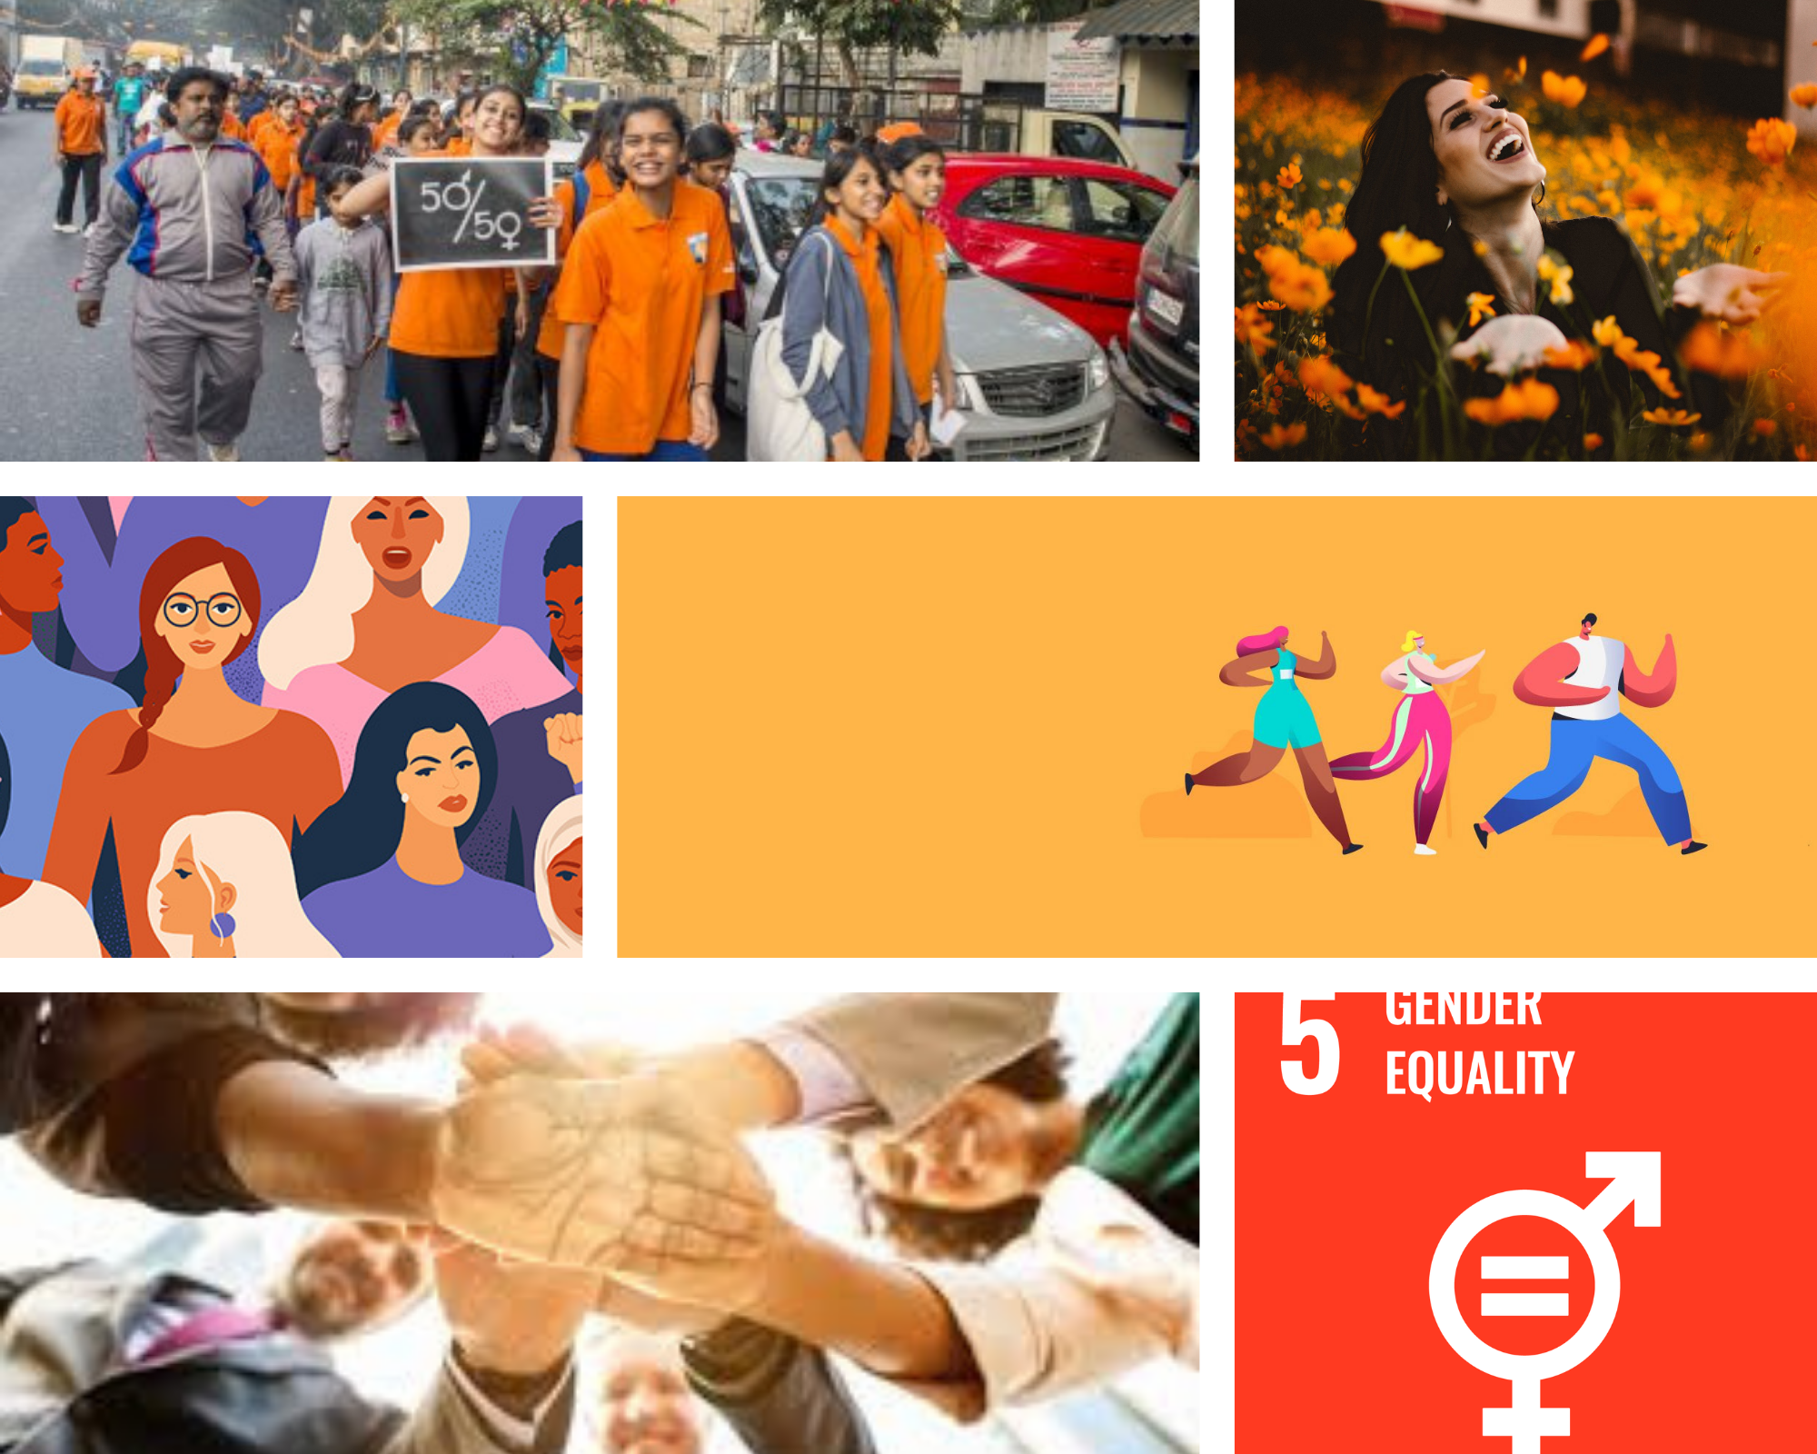

Sketches

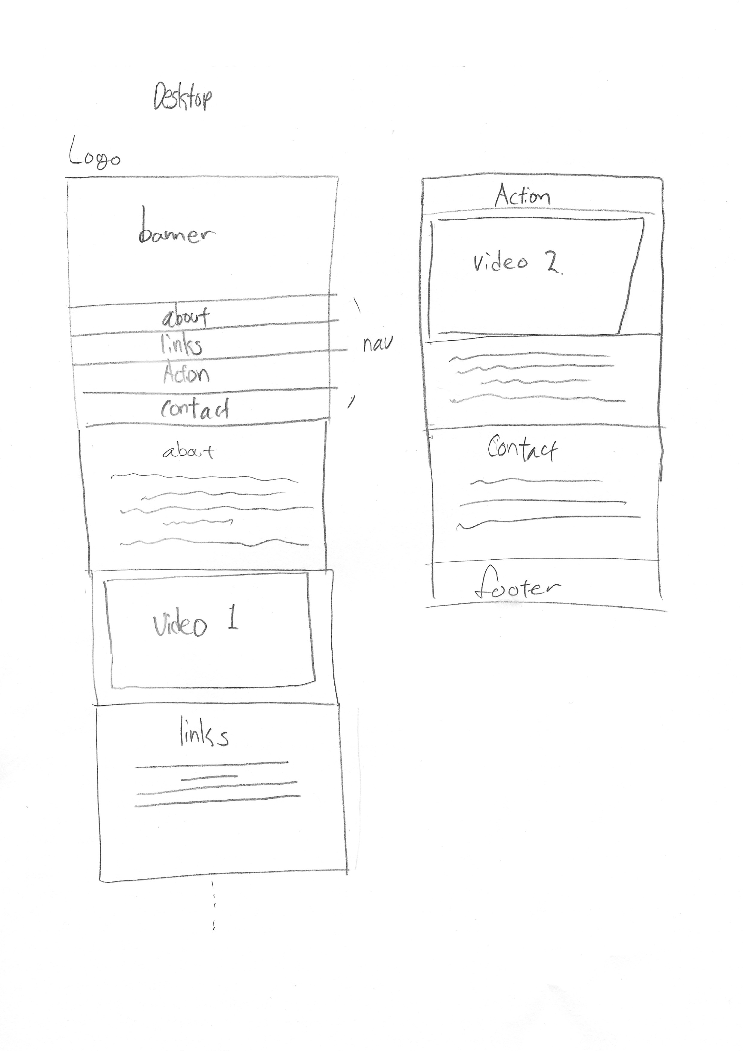

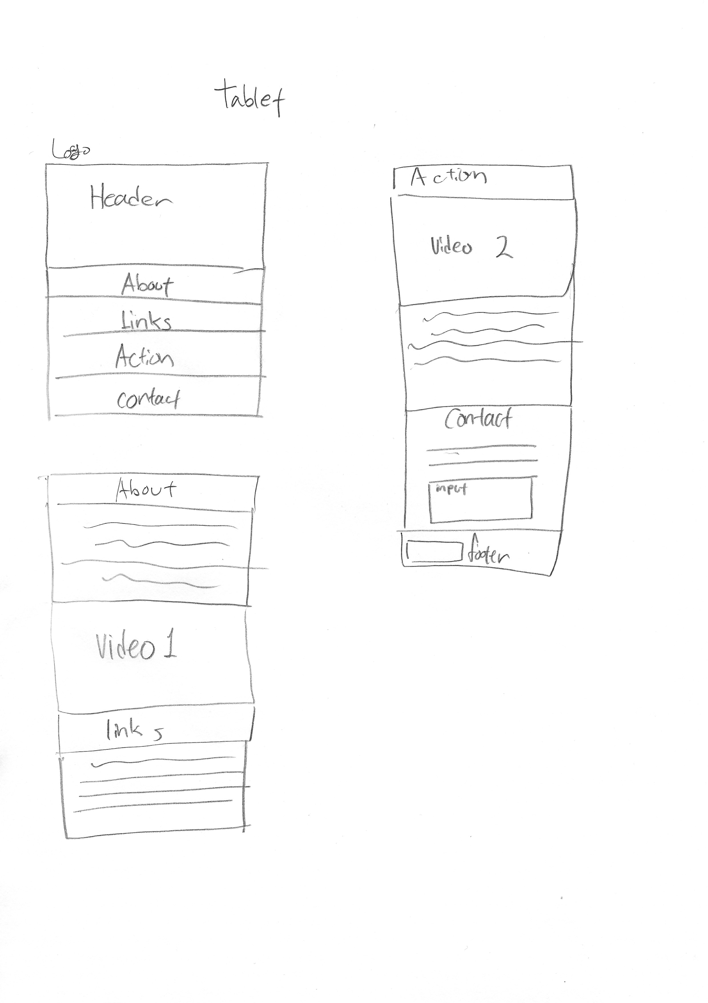

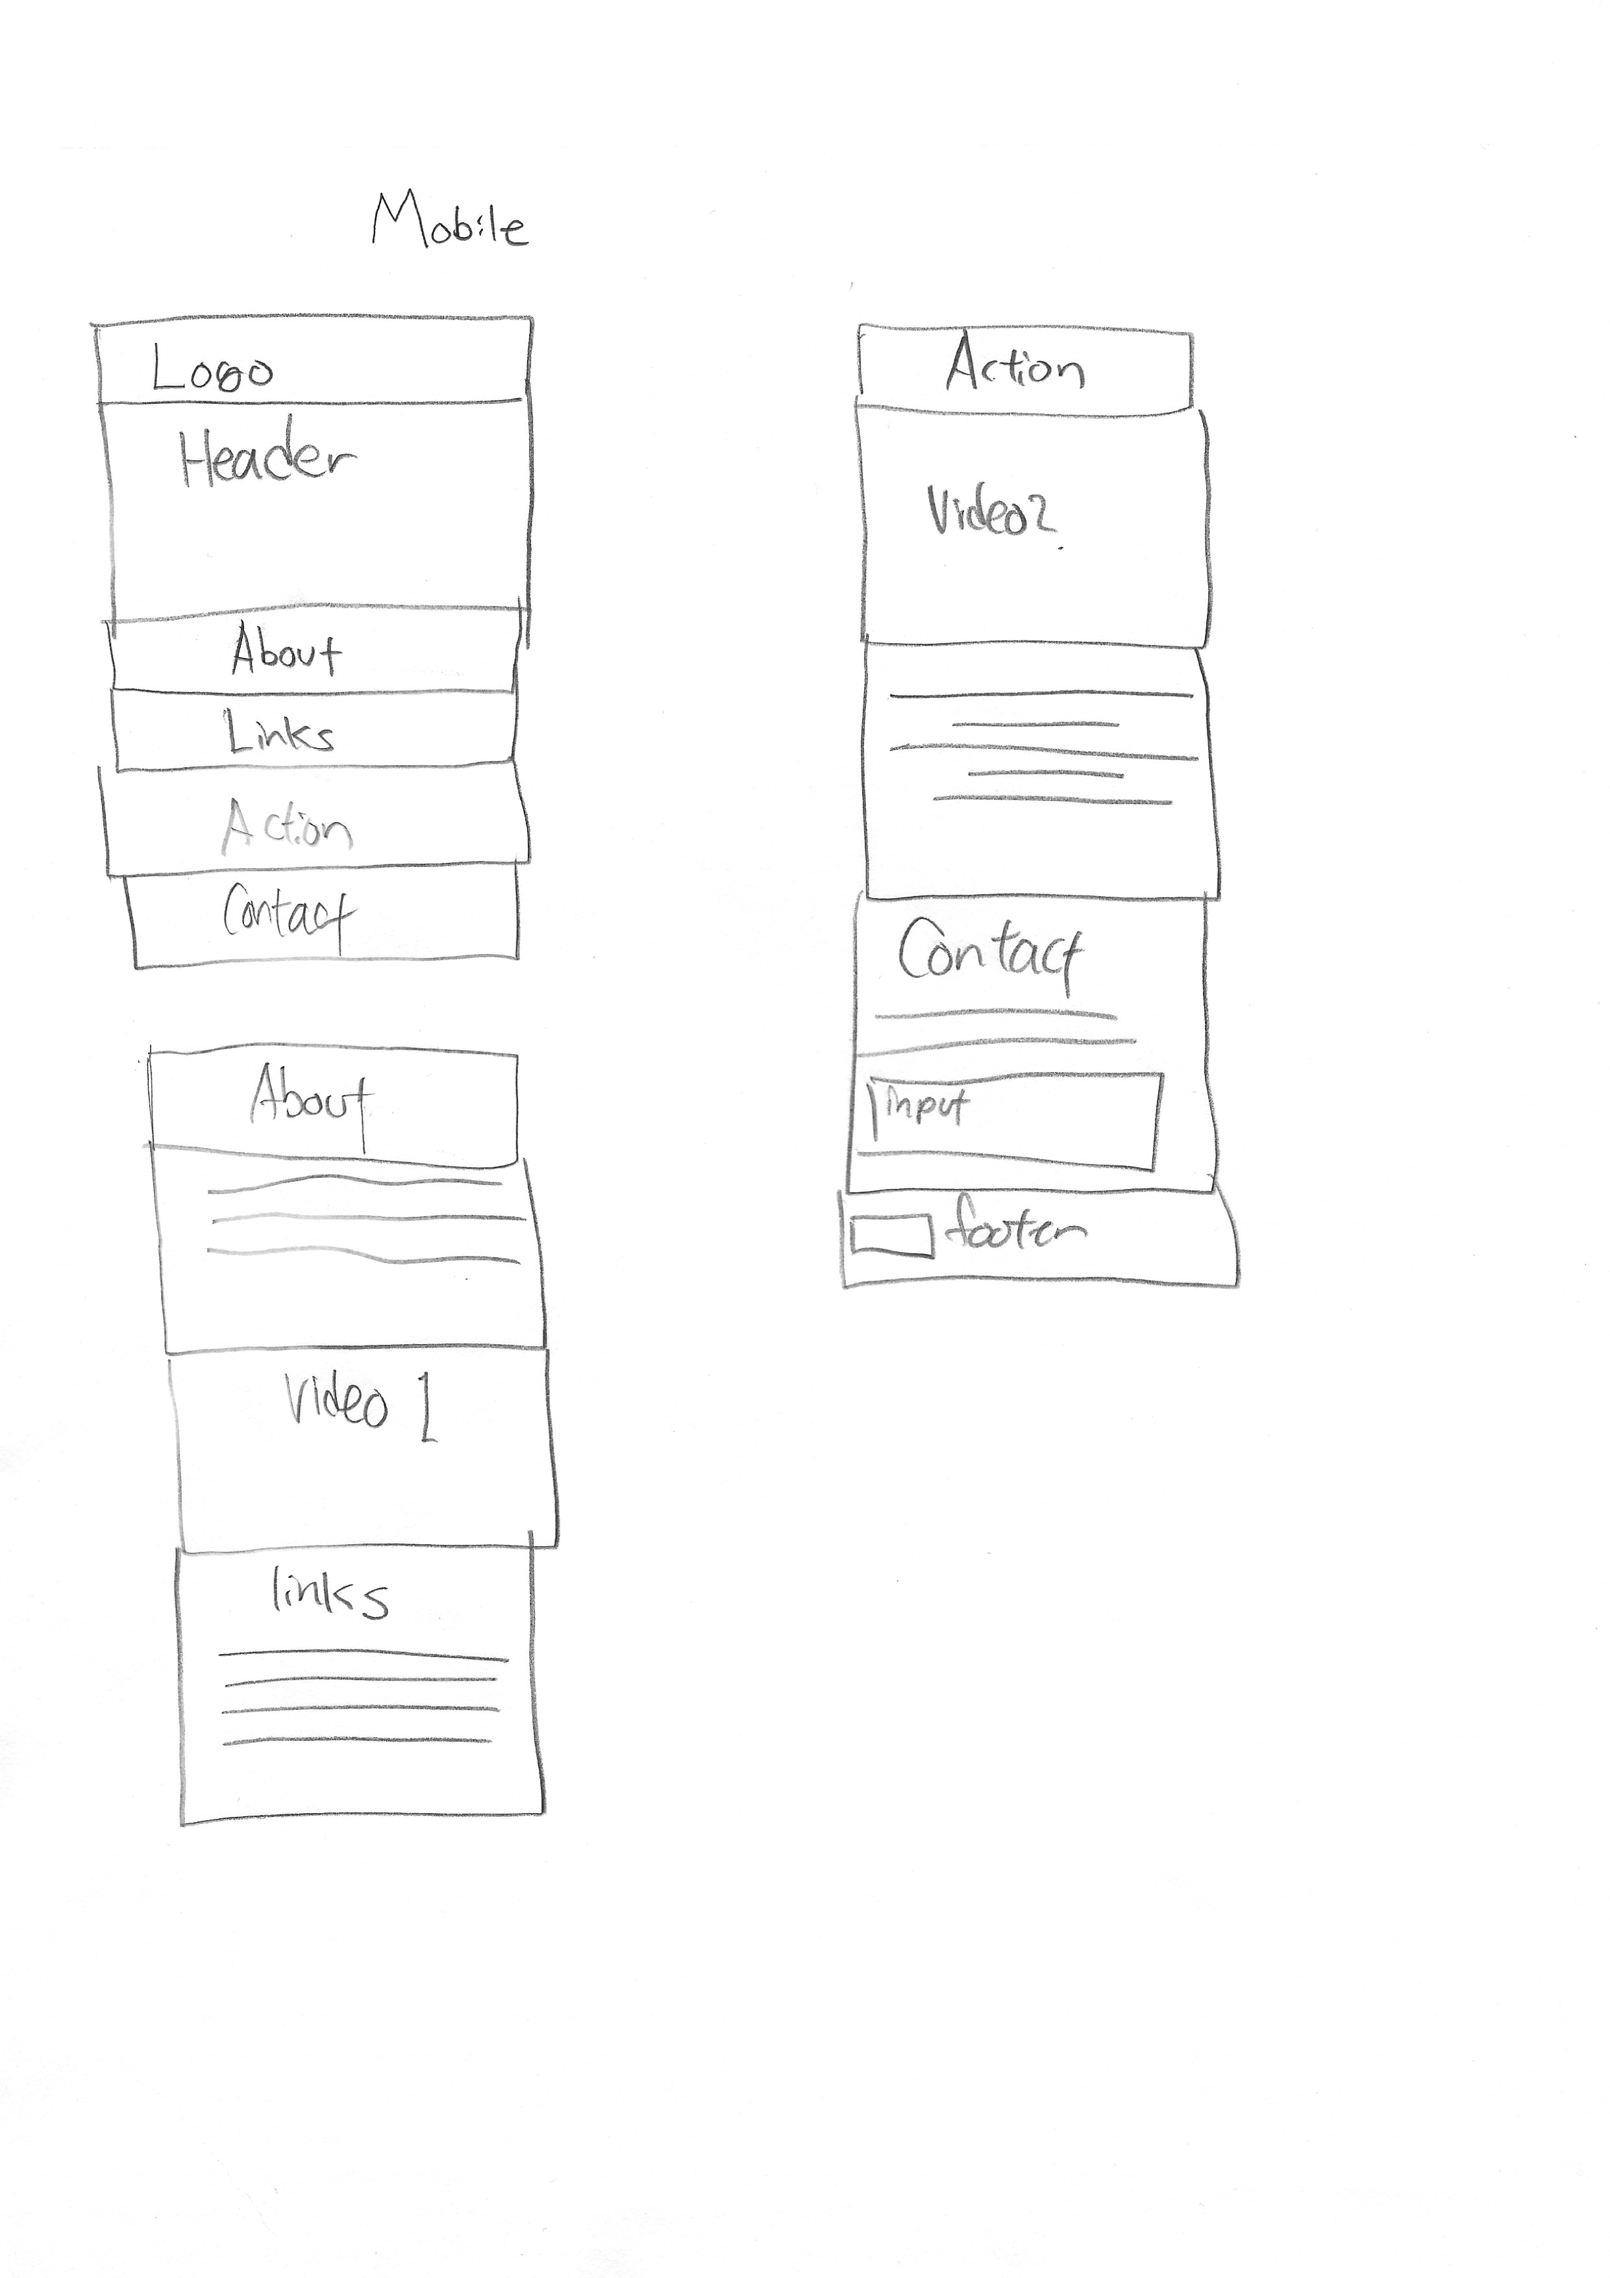

Wireframe (Desktop)

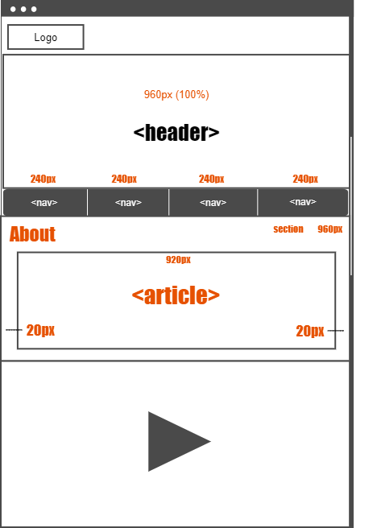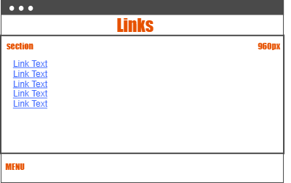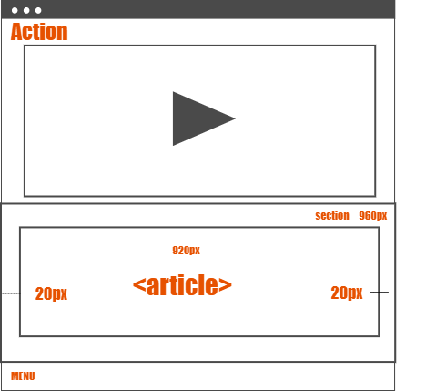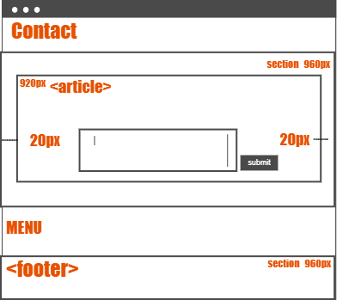

Wireframe (Mobile, Tablet)

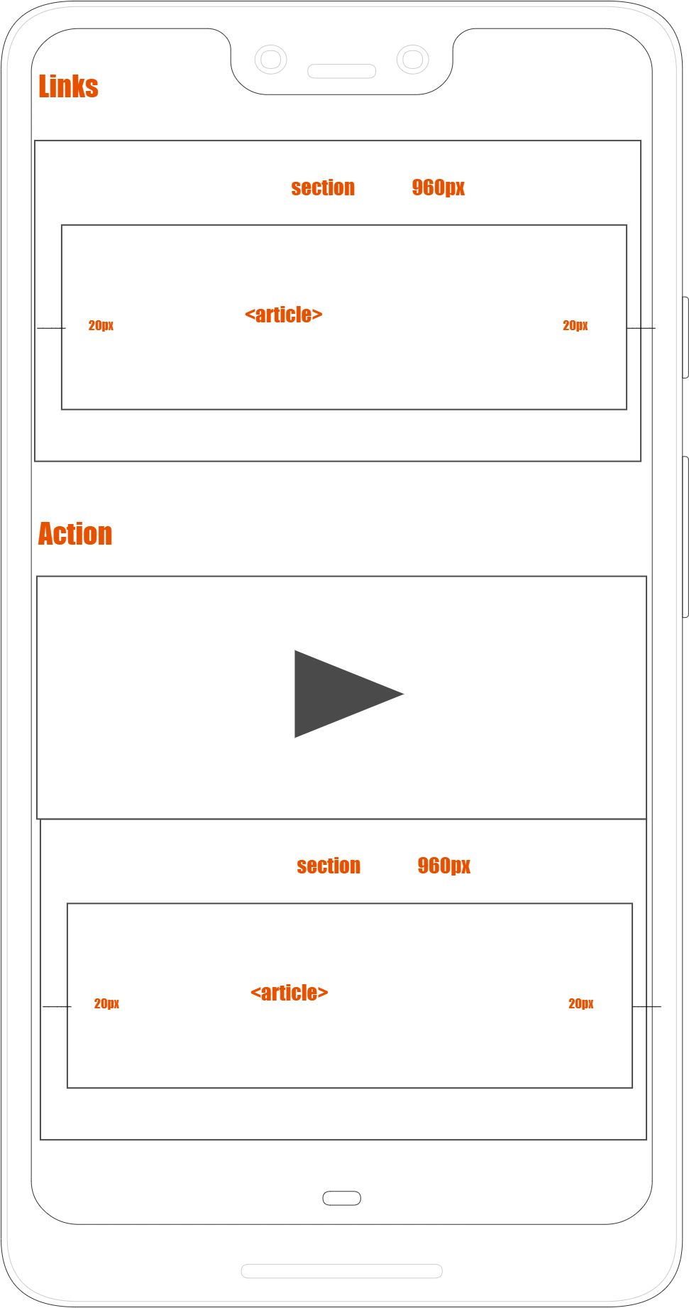 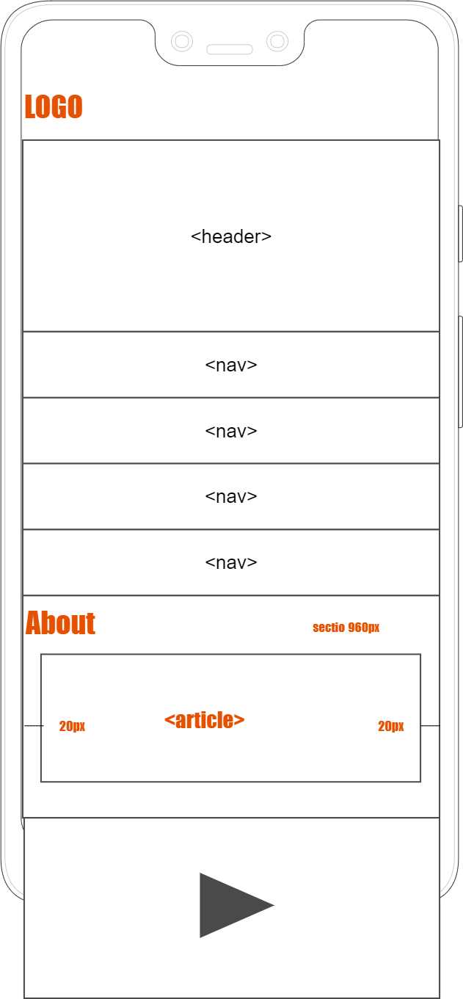

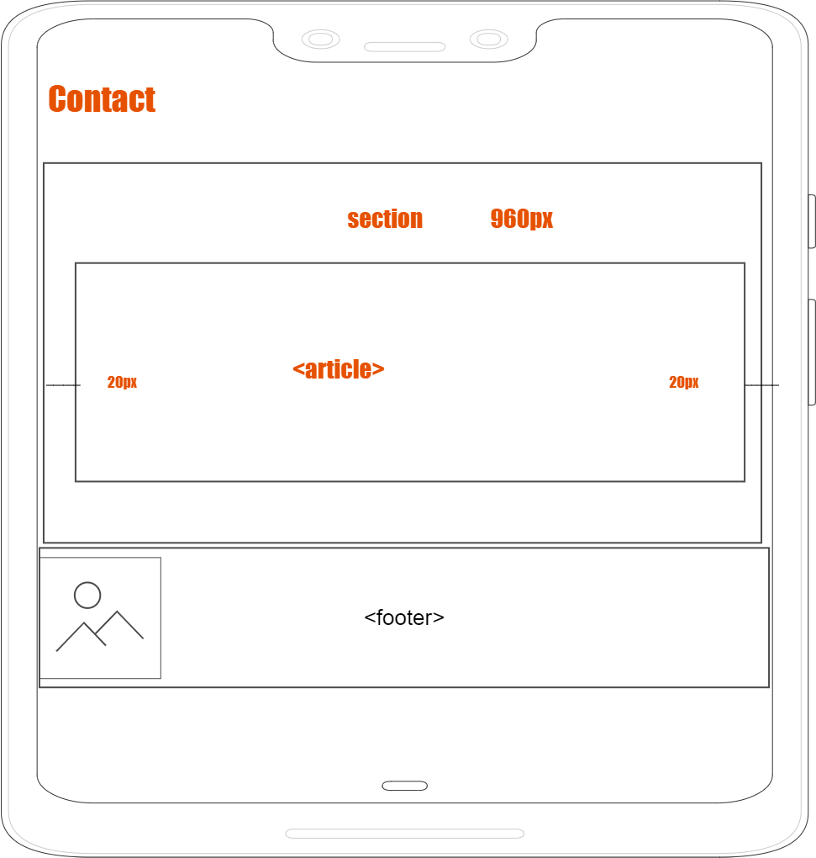

Font Sample

Impact

ABCDEFGHIJKLMNOPQRSTUVWXYZ

1234567890

Arial Balck

ABCDEFGHIJKLMNOPQRSTUVWXYZ1234567890

Courier New

ABCDEFGHIJKLMNOPQRSTUVWXYZ

1234567890

Site map

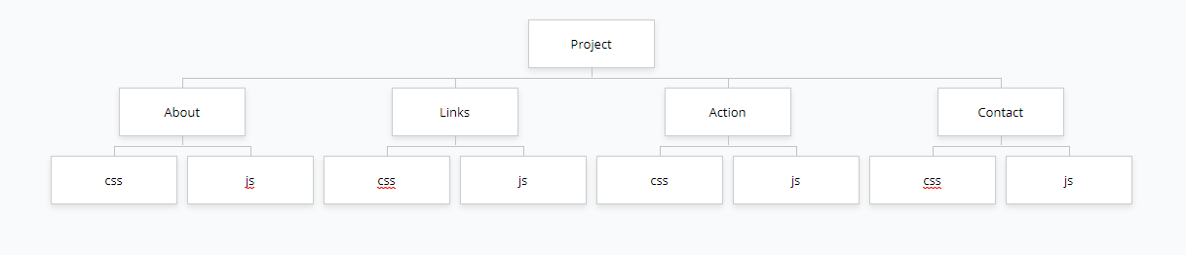

Color palette

**#ef402d R: 239 G: 064 B: 045**

**#cb07f2 R: 203 G: 007 B: 242**

**#000000 R: 000 G: 000 B: 000**

**#ffffff R: 255 G: 255 B: 255**

Mock-ups (Desktop)

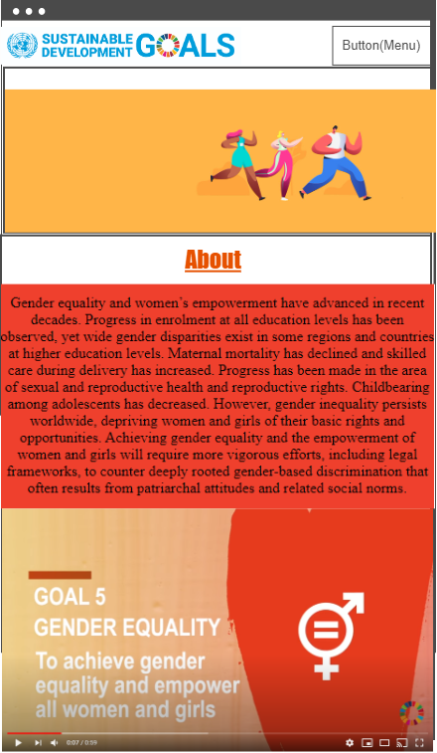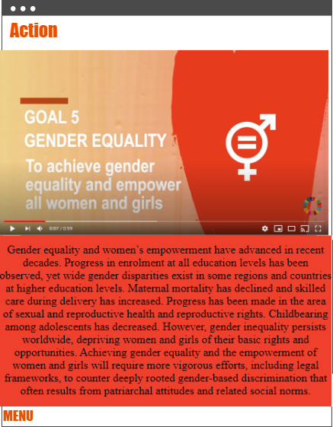

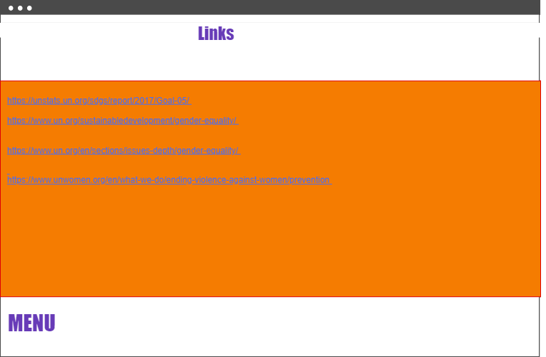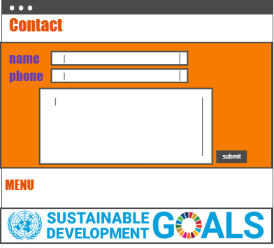

Mock-ups (Mobile, Tablet)

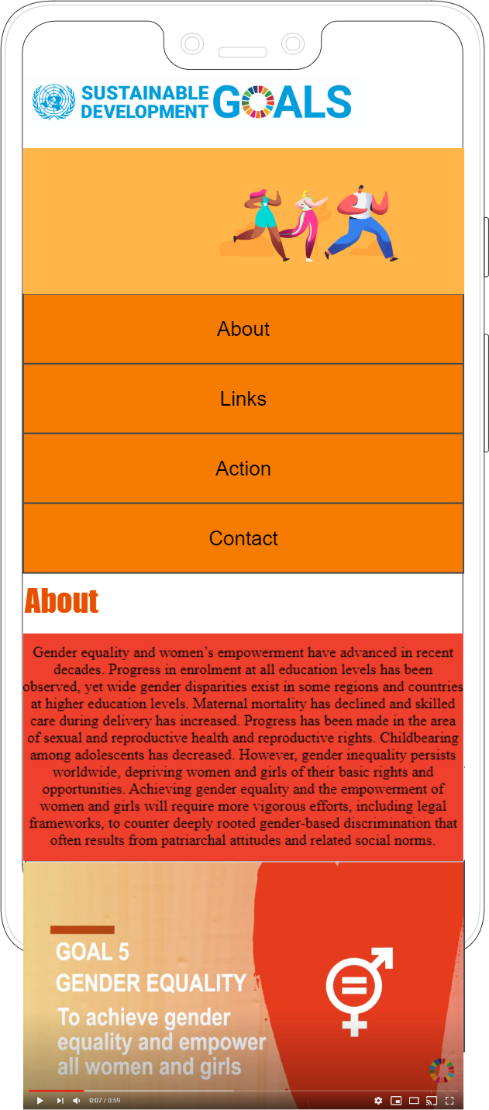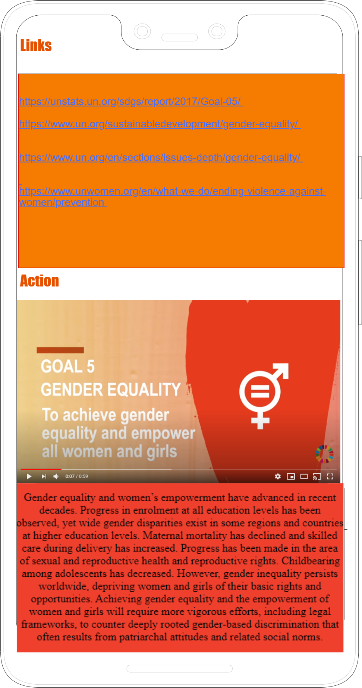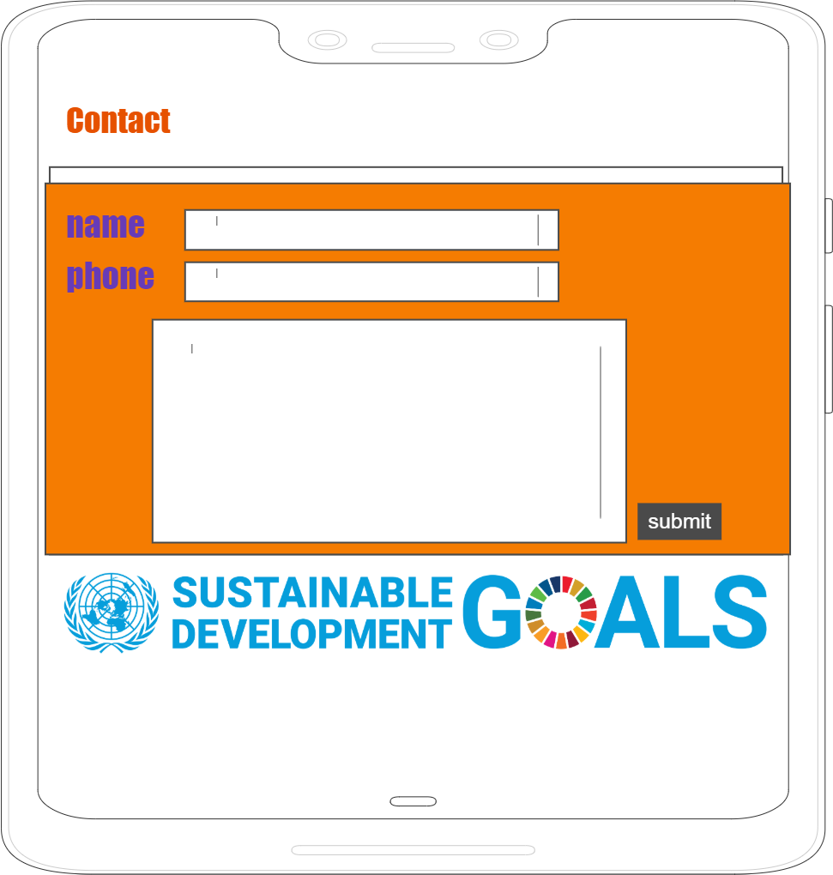

Links

[**https://unstats.un.org/sdgs/report/2017/Goal-05/**](https://unstats.un.org/sdgs/report/2017/Goal-05/)

[**https://www.un.org/sustainabledevelopment/gender-equality/**](https://www.un.org/sustainabledevelopment/gender-equality/)

[**https://www.un.org/en/sections/issues-depth/gender-equality/**](https://www.un.org/en/sections/issues-depth/gender-equality/)

[**https://www.unwomen.org/en/what-we-do/ending-violence-against-women/prevention**](https://www.unwomen.org/en/what-we-do/ending-violence-against-women/prevention)

<https://www.un.org/en/sections/issues-depth/gender-equality/index.html>